**Day 4 Implementation Report**

1. **These are the products displayed on front end from sanity**

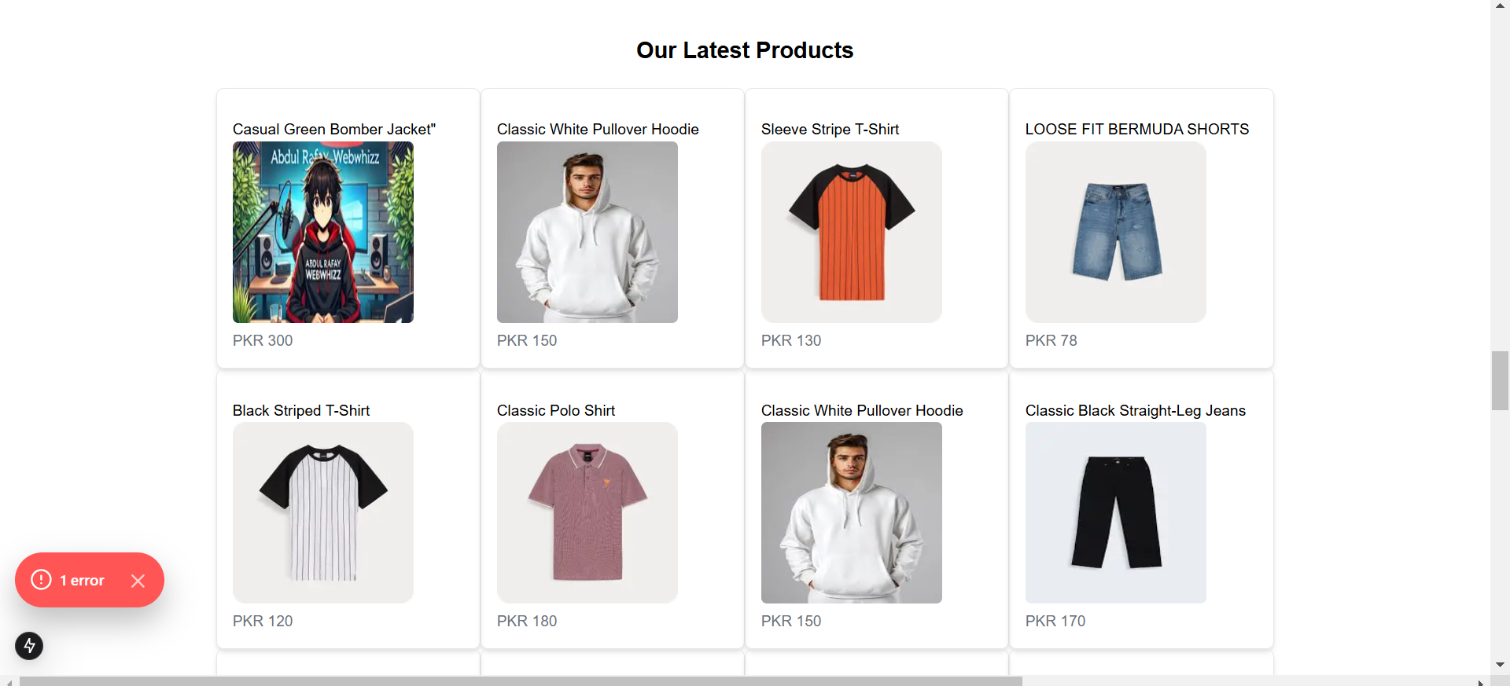

1. **This is the interface of product showing its title , image and price.**

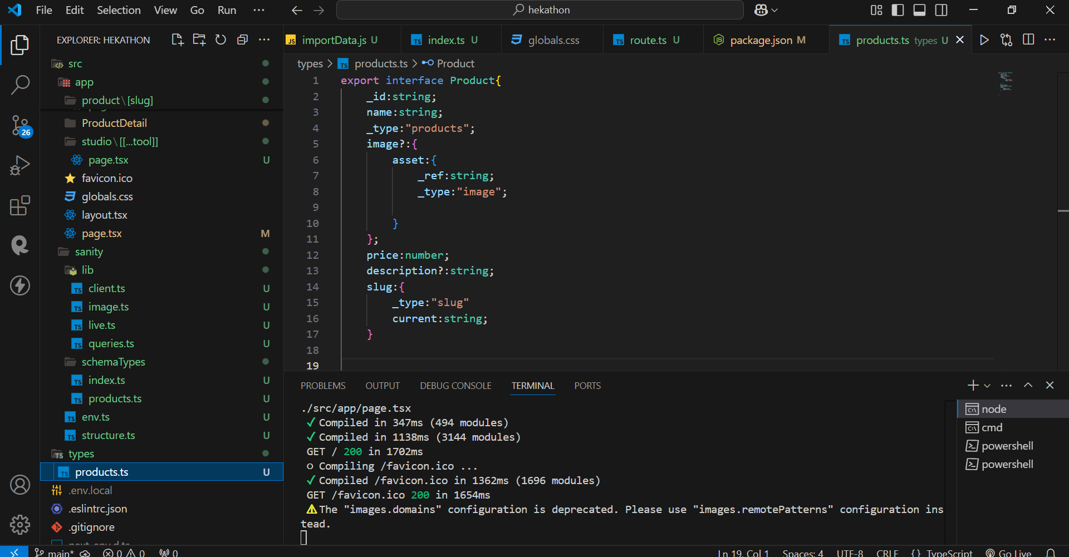

1. **Groq query for products in sanity**

